MANTSOPA LOCAL MUNICIPALITY :SUPPLEMENTARY VAL ROLL - 3- (2025 / 2026)

CERTIFICATION BY MUNICIPAL VALUER AS CONTEMPLATED IN SECTION 34(c) OF THE ACT- No 6 of 2004.
I, Ettienne E Pretorius , Identity Number 6109055039088 , do certify that I have, in accordance with the provisions of the Local Government: Municipal Property Rates Act, 2004 (Act 6 of 2004as revised ), hereinafter referred to as the ‘Act’, to the best of my skills and knowledge and without fear, favour or prejudice, prepared the Supplementary valuation roll for : MANTSOPA Local Municipality in terms of the provisions of the Act. In the discharge of my duties as the Municipal Valuer I have complied with sections 43 and 44 of the Act.
Certified and rectified at Potchefstroom this 31 March 2026.
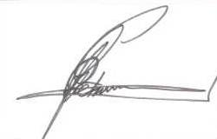
Proff Valuer no 558.
Municipal Valuer – Mantsopa Local Municipality
EE Pretorius

